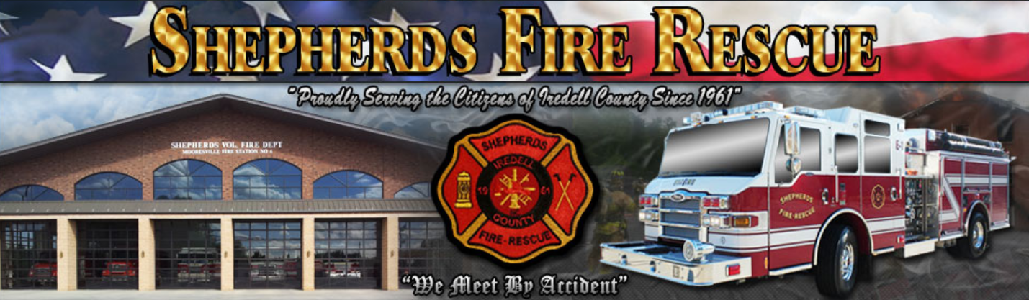

**SHEPHERDS FIRE – RESCUE IS RECRUITING FOR THE POSITION OF FIREFIGHTER / E.M.T. - BASIC**

6 (six) Career Full-time Firefighter positions and multiple Part-time Firefighters will be hired as we transition to 24/7/365 staffing.

Please indicate which position you are applying for on the application.

Learn more about Mooresville, NC: <https://www.racecityusa.org/>

**Application Packets will be Accepted: December 9th 2019 – January 3rd, 2020 (at 5:00 p.m.).**

|  |  |
| --- | --- |
|  |  |
| **FULL TIME POSITION DETAILS** | **CURRENT BENEFITS SUMMARY** |
| Salary: $35,000 / year | Comprehensive Medical Coverage |
|  | Long-term Disability Insurance |
|  | Deferred Compensation Plan |
| Expected Shift Schedule: 24 – 48 (A,B,C Shifts) | Wellness Program |
| *Alternate shift assignments may occur* | Tuition Reimbursement |
|  |  |
| **PART TIME PAY RATE: $15 / hour** |  |

**THE PHYSICAL AGILITY TEST AND ORAL INTERVIEWS WILL BE ON:**

**JANUARY 13TH & 14th, 2020.**

**(Repeat Physical Agility test is January 14th if necessary)**

**THE STARTING DATE WILL BE THE WEEK OF MARCH 9TH 2020.**

# MINIMUM QUALIFICATIONS:

**The requirements listed below must be submitted by the application deadline of January 3rd, 2020.**

* **Age Requirement:**
  + Candidates must be at least 18 years of age or older by March 9, 2020.
* **Education Requirement:**
  + Candidates must have a high school diploma or have passed an equivalency test (GED).
* **Driver’s License:**
  + Candidates must possess a valid driver's license and be insurable under the Department's vehicle policy.
  + A valid North Carolina driver’s license shall be obtained by date of hire. (Verification required.) Class B license is preferred, and required upon employment.
* N**orth Carolina Firefighter II Certification:**
  + National IFSAC certifications are usually accepted. Confirmation with the North Carolina Office of the State Fire Marshal will be required.
* **North Carolina Emergency Vehicle Driver Certification**
* **EMT-Basic (NC or NREMT), CPR (AHA BLS-C)**
* **Haz-Mat Operations**

**PREFERRED QUALIFICATIONS**

* Driver Operator – Pumps Series
* Technical Rescue Certification in Vehicle & Machinery Rescue, Agricultural Rescue, Ropes Specialty
* Experience with written communications and technology
* BlueCard IC Certification
* College degree / vocational certificate
* Records of relevant training and experience
* Experience in public/community service, customer service/relations
* Fluent in additional language(s)

**DESIRABLE TRAITS AND QUALITIES:**

* Enthusiasm/Desire for public service
* Mechanical aptitude/experience
* Basic computer skills and information technology competencies
* Interpersonal skills, ability to relate to others, effective oral communication skills
* High level of ethical standards and moral integrity
* Ability to deal with adversity/physical and emotional stress
* Empathy, concern for others, ability to interact with people from diverse backgrounds
* Interest/experience in working in a team-oriented environment
* Commitment to a high level of physical fitness
* Understanding of Shepherds Fire – Rescue’s public image and it’s importance
* Ability to work under unpredictable hazardous conditions such as suppressing a fire or responding to an emergency medical call.
* Ability to work in an outdoor environment subject to extremes of temperature, inclement weather, and intermittent exposure to dust, fumes, and loud noise.

### APPLICATION REQUIREMENTS

* **Pickup or download the application packet** at Shepherds Fire Station #1, 2014 Charlotte Hwy, Mooresville, NC, 28117 or at [www.shepherdsfire.com](http://www.shepherdsfire.com)
* **Submit an application** by the deadline and include the following:
  1. Complete the “**Shepherds Fire - Rescue Employment Application**”
  2. Write a one-page letter of interest stating your reason to apply and why you feel that you would be a good candidate for a position with Shepherds Fire - Rescue.
  3. Submit a resume summarizing your experience, skills, and abilities to meet the stated minimum requirements, preferred qualifications, and qualities for the position of Firefighter. Resume shall be limited to 3 pages.
  4. Include **OPTIONAL** - Letter of reference – 1 page maximum
  5. Complete the “Release for Background Check” form
  6. Include “Form DD214” if you are a Veteran

**Submit the completed application packet to:**

**Shepherds Fire – Rescue**

**Attn: Employment**

**2014 Charlotte Highway**

**Mooresville, NC 28117**

**or**

[**employment@shepherdsfire.com**](mailto:employment@shepherdsfire.com)

***Application Packets must be received by 5 P.M., January 3rd, 2020.***

## TERMS AND CONDITIONS

**Veteran’s Preference:** Candidates requesting Veteran’s preference will be asked to submit documentation (a long-form DD214) which indicates the nature of the discharge in order to receive Veteran’s preference points. Preference points are only added to passing scores.

**Reasonable Accommodation**: In compliance with the American with Disabilities Act (ADA), Shepherds Fire - Rescue will make reasonable accommodation during any and all phases of the selection process for individuals with a disability. Please contact [employment@shepeherdsfire.com](mailto:employment@shepeherdsfire.com) by the application deadline date to request accommodation.

**Equal Opportunity Policy Statement:** Shepherds Fire - Rescue provides equal employment opportunities (EEO) to all employees and applicants for employment without regard to race, color, religion, gender, sexual orientation, gender identity or expression, national origin, age, disability, genetic information, marital status, amnesty, or status as a covered veteran in accordance with applicable federal, state and local laws.

**Disclaimer:** The provisions of this hiring notice do not constitute a contract, expressed or implied, and any provisions contained in this notice may be modified or revoked at the discretion of the Department.