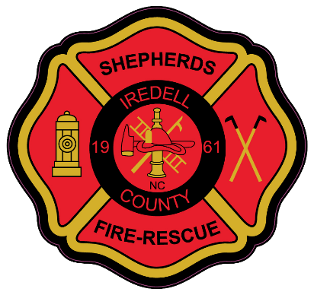

**SHEPHERDS FIRE – RESCUE, INC.**

**2014 CHARLOTTE HWY * MOORESVILLE NC 28117 * 704-663-1245**

**PHYSICAL AGILITY TEST**

The Physical Agility Test consists of Six separate events that test the applicant’s ability to complete the daily physical requirements of a Firefighter. During the test, applicants will progress along a predetermined path from event to event in a continuous manner. This test was developed to assist Shepherds Fire – Rescue to obtain a pool of candidates that are physically able to perform the essential job tasks of a Firefighter.

**THE PHYSICAL AGILITY TEST IS PASS / FAIL – MAXIMUM TIME IS 20 MINUTES**

**Weight vest and Clothing**

During the test, applicants will wear a 50-pound (22.68-kg) vest to simulate the weight of a self-contained breathing apparatus (SCBA) and Firefighter personal protective equipment (PPE).

Candidates should wear climate appropriate station uniform type clothing with closed toed shoes.

**Event #1- Deploy 200’ Cross lay**

This event is designed to simulate the critical task of stretching a 200’ crosslay in a quick and efficient manner to a predetermined area. The Candidate will call for water when ready.

**Event #2- KEISER FORCE MACHINE**

This event simulates using force to open a locked door or to breach a wall. This evolution utilizes the Keiser Force Machine (a chopping simulator). Using the 10-lb shot mallet provided, the applicant must drive the sled; a 160-lb steel beam a horizontal distance of 5-ft. Pushing, raking or hooking the beam is not allowed; only the head of the mallet is allowed to strike the beam.

**Event #3- 2.5” Handline move and flow**

This event simulates the critical task of moving a large hose line and flowing. The candidate will pick up the hose and move straight forward approximately 50’ and open the nozzle and knock over a cone approximately 50’ away.

**Event #4- Ladder carry and raise**

This event the candidate will pick up the ladder and carry in the manner they so choose, place the ladder against the adjacent building at the proper angle.

**Event #5- Highrise carry and raise**

This event the candidate will pick up the 50’ bundle high-rise pack and walk to the top of the stairs. The candidate will grab the rope that is tied off at the top of the stairs and lift hand over hand the rolled 50’ 2.5” section. Bring the hose roll over the rail touch the floor and then lower back down to the ground hand over hand. The candidate will then return to the bottom of the stairs and drop the high-rise pack at the bottom.

**Event #6 Victim Drag**

The is event the candidate will grasp the 185lb Victim mannequin and drag it approximately 50’ across the finish line.

**This concludes the test.**